**Assignment- 10-May-2022:**

**Hands On Activity which needs to be documented:**

1. **Create an S3 bucket and upload html data in txt file**

**To create a bucket … Go to S3 and click on create bucket as shown in below.**

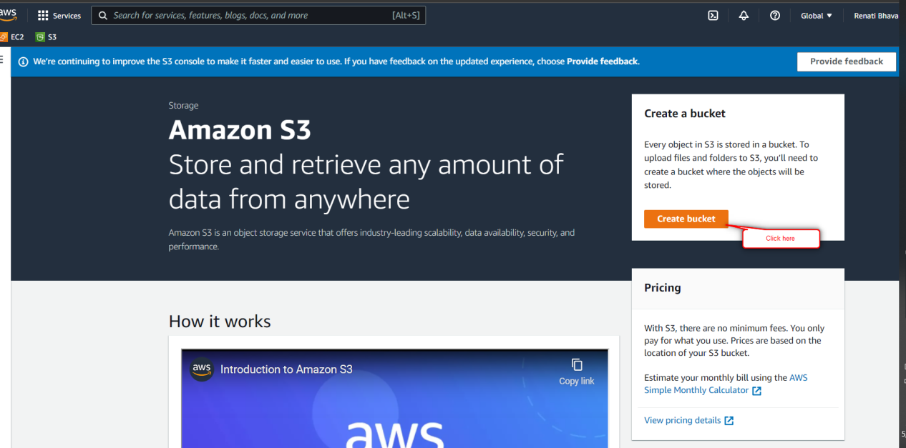

**Give bucket name and region and enbale the ACLs, uncheck the block of public access. And click on create button.**

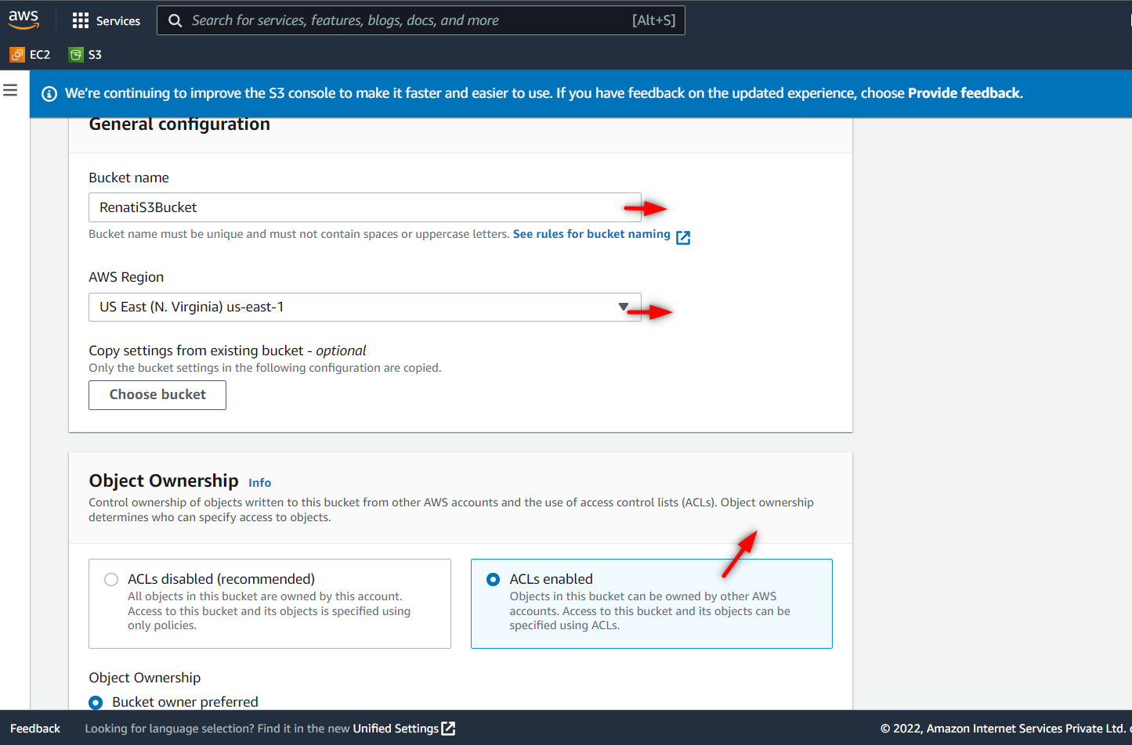

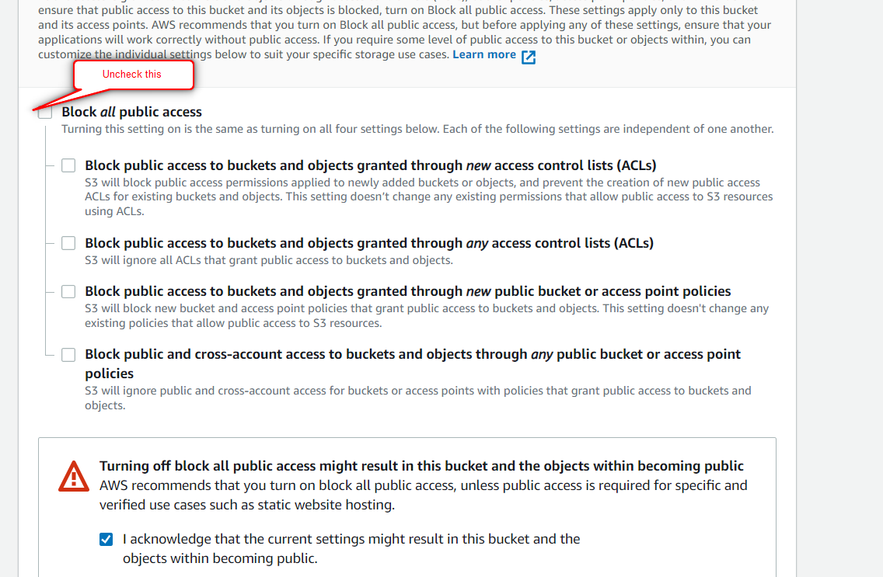

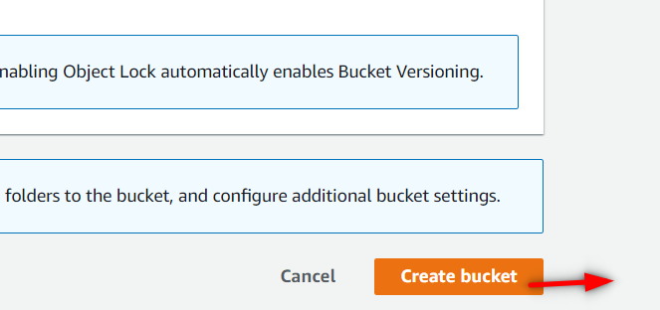

**See the bucket is created.**

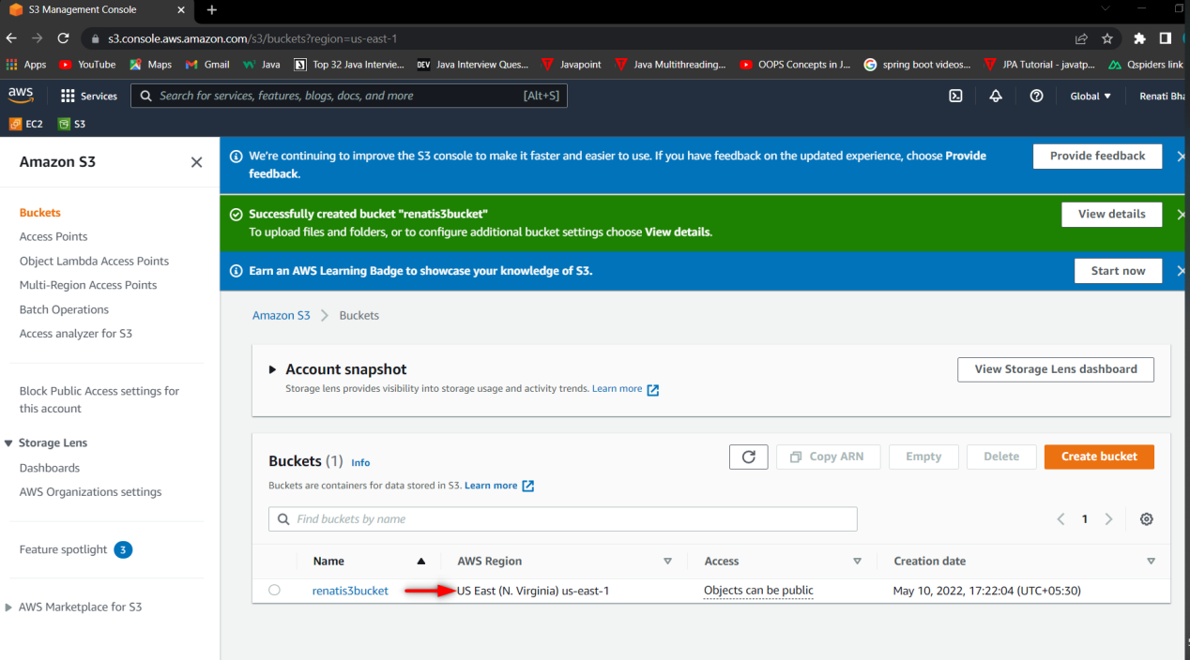

**Now upload the object/files in the bucket. To do this click on Upload button and again click on add files and add the files.**

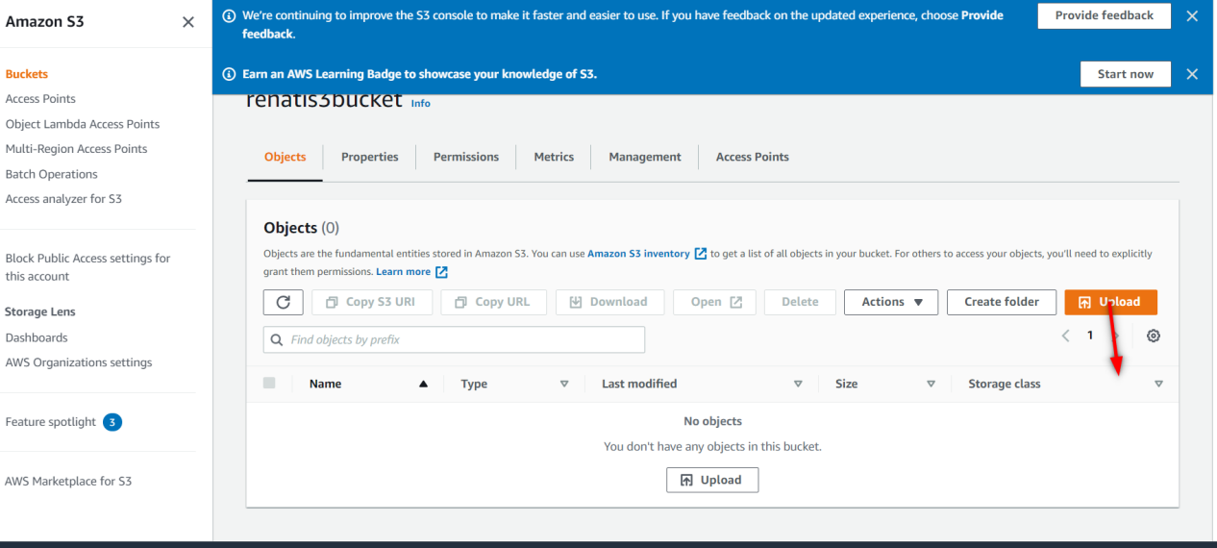

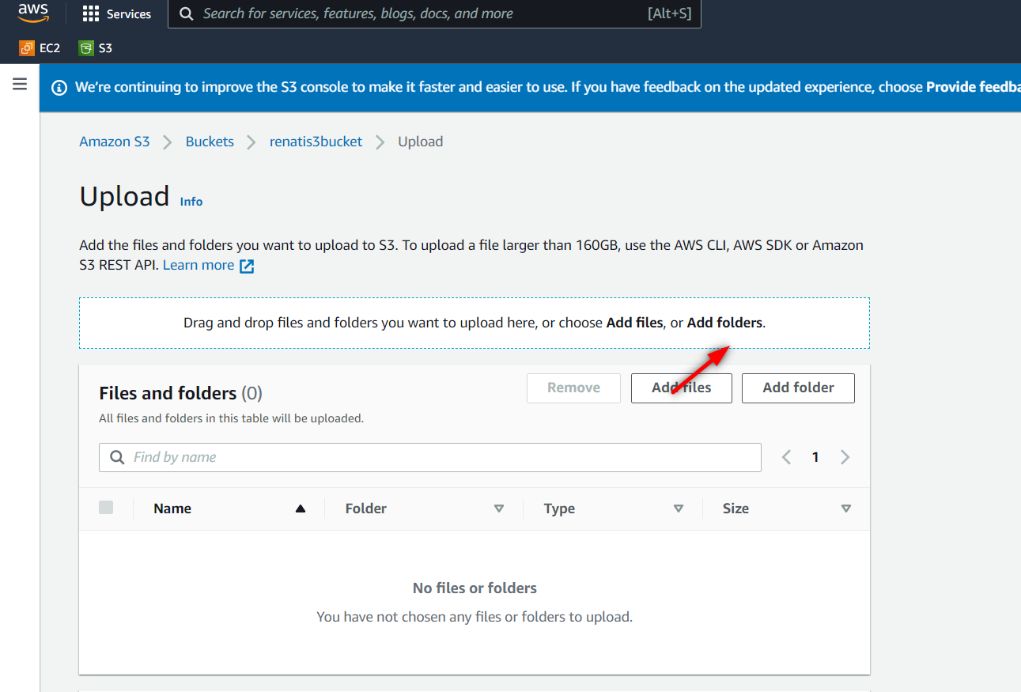

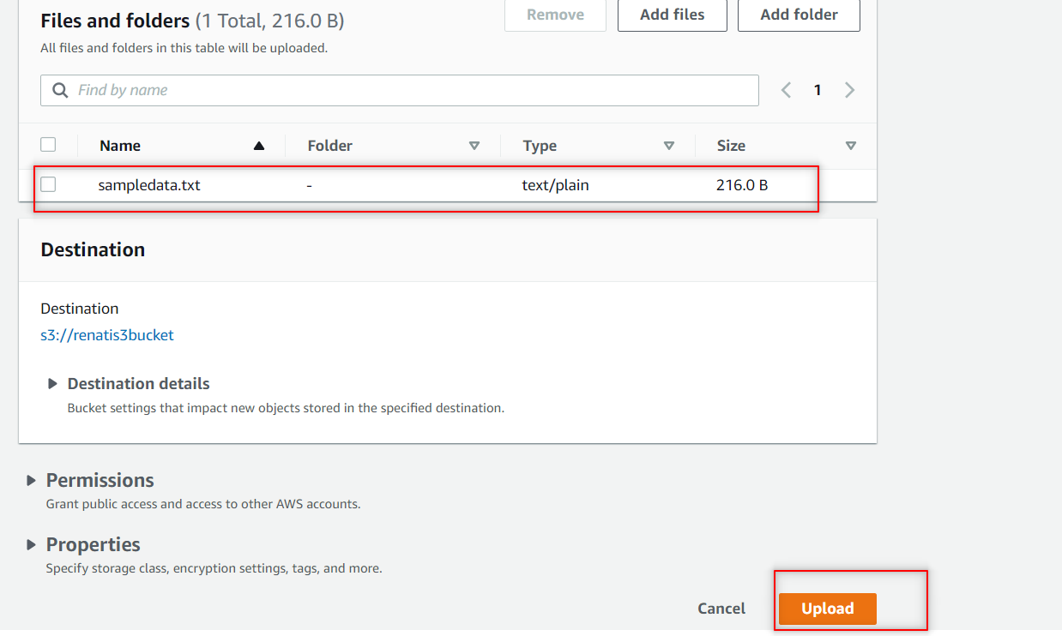

**Now click on permission under bucket level to provide permission to publicly access check the two buttons..**

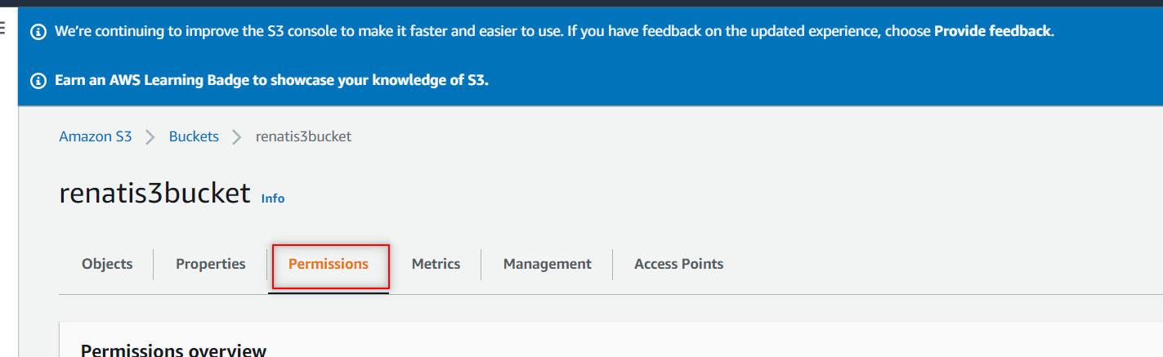

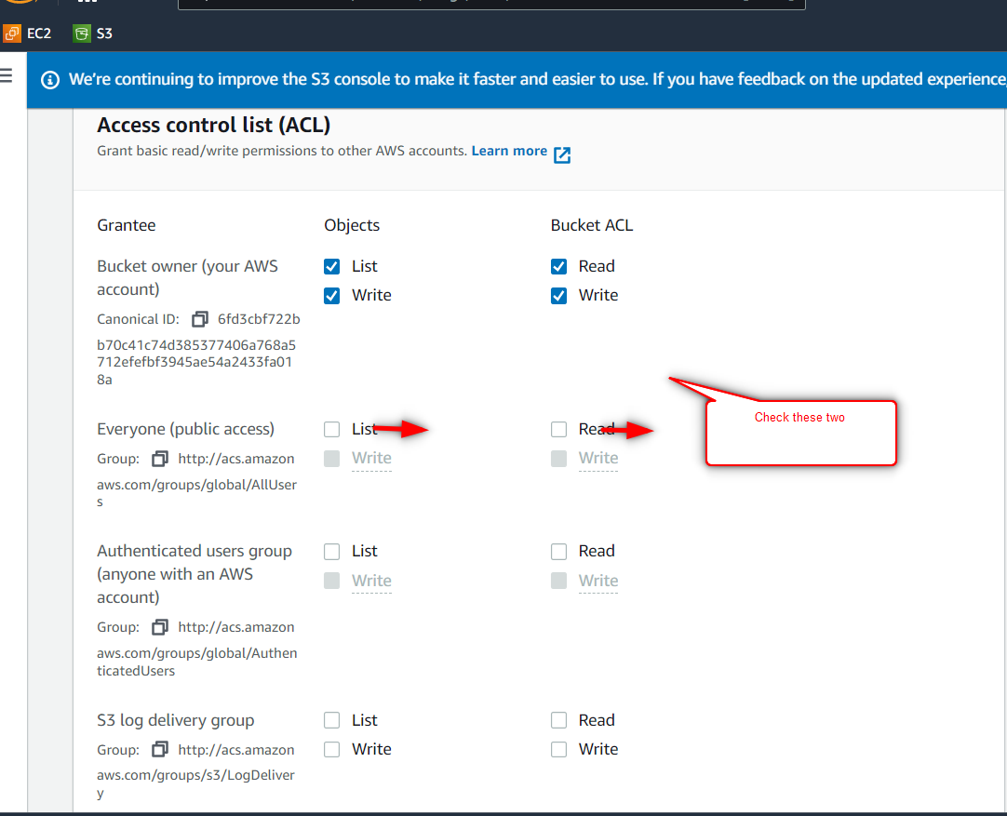

**Here u can see the bucket is publicly accessible.**

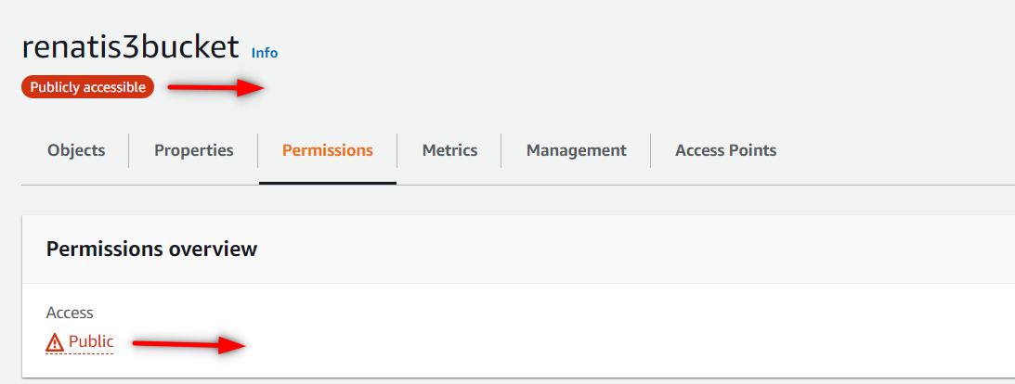

**Now do the same thing under object level and copy the url and paste it in google to see the data.**

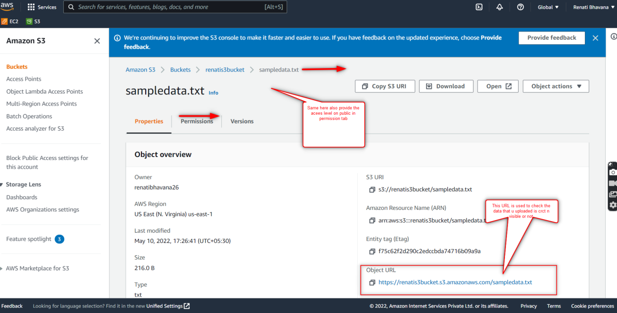

1. **Create a role if s3 read only is not available ?**

**Go to IAM ,click on Roles and click on Create role.**

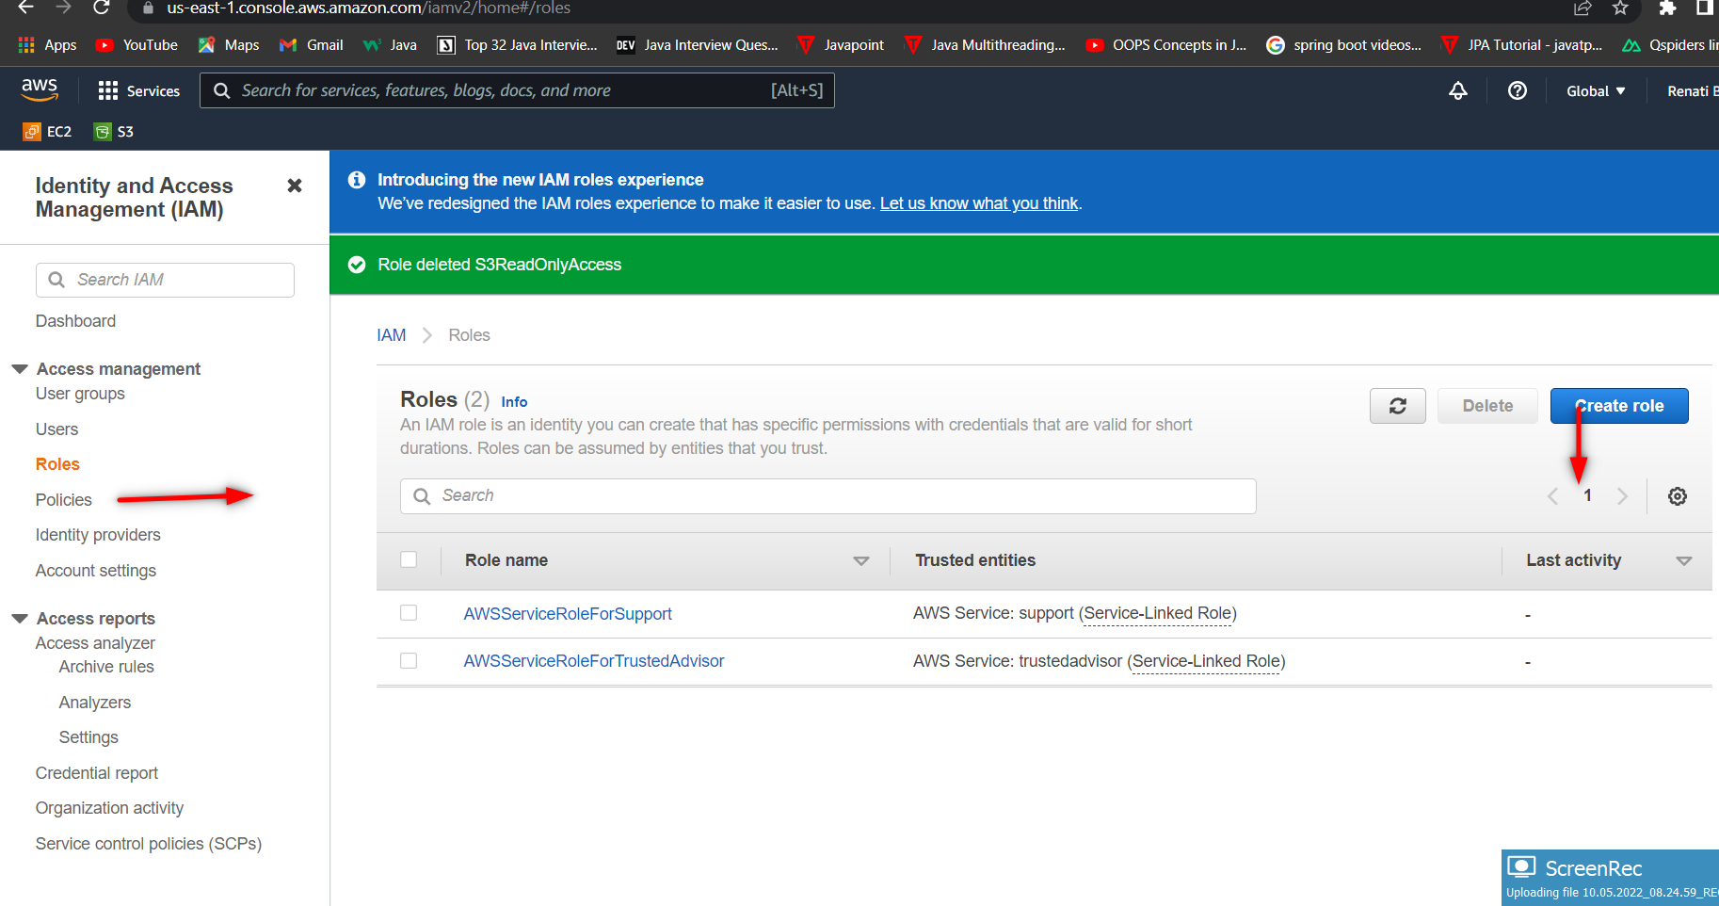

**Here provide the proper details as shown below**

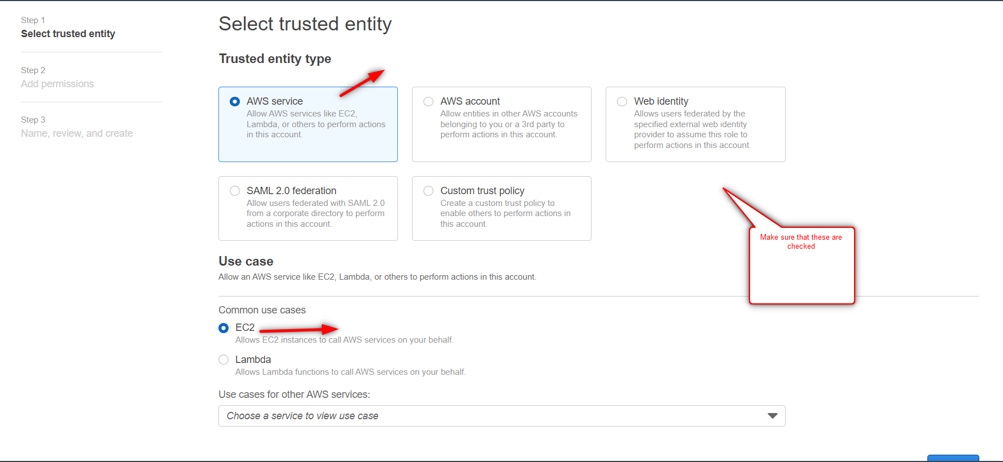

**Here search for S3ReadAccessOnly and click that one and click on next.**

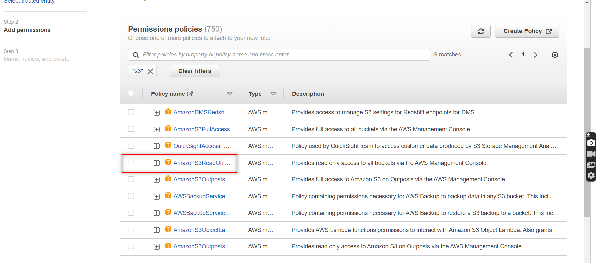

**Here provide the role name and see other details as well and create role.**

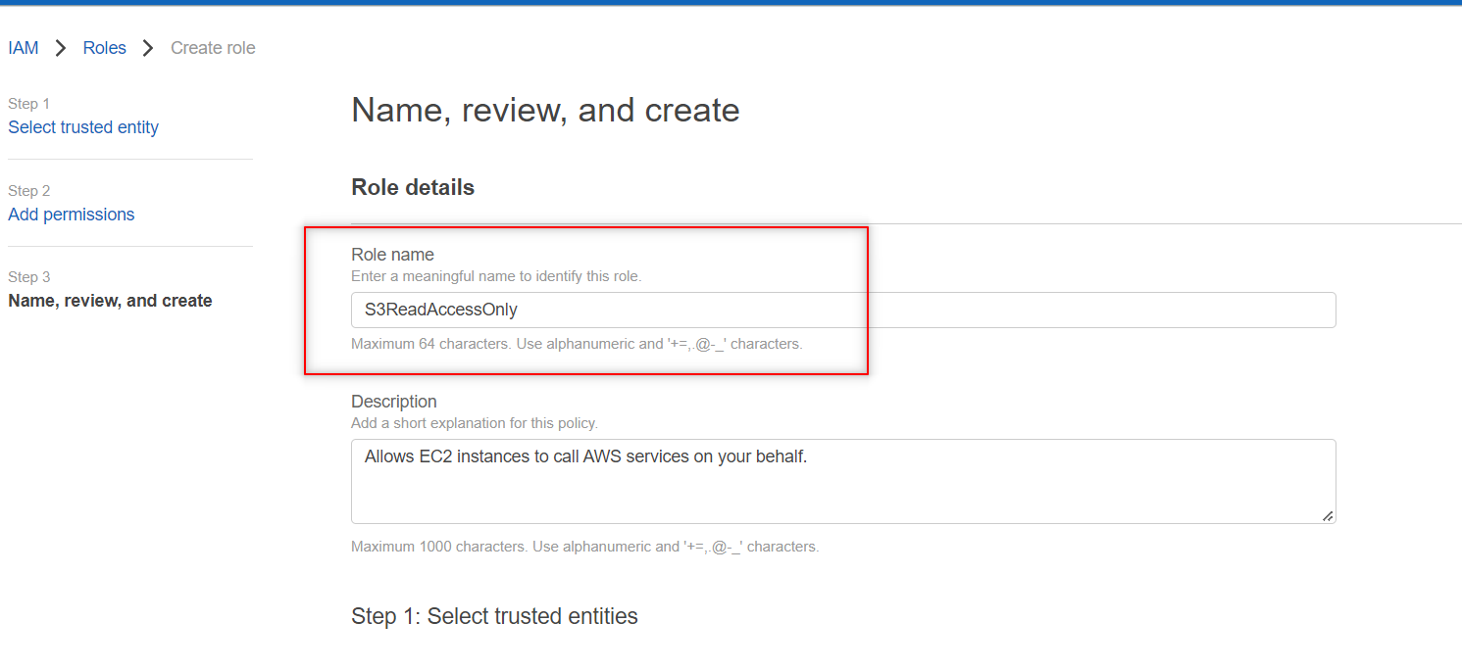

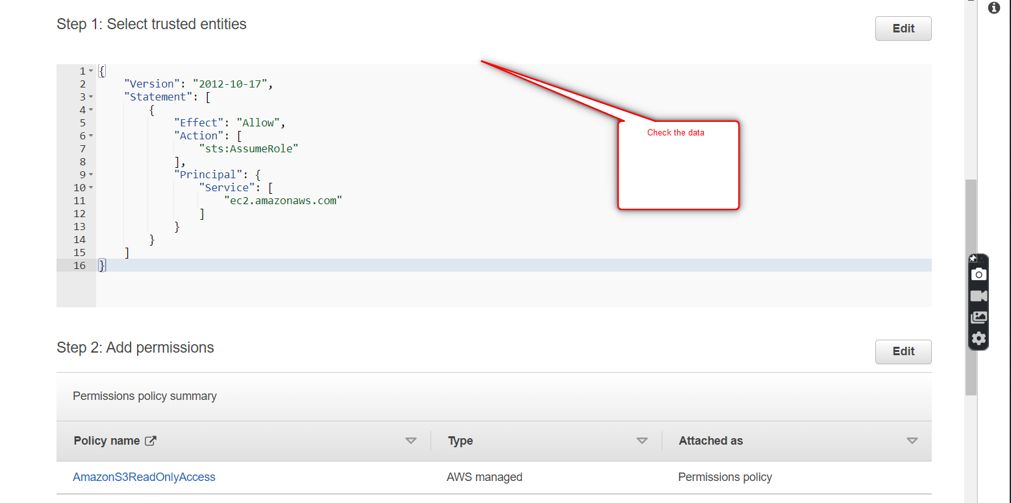

**Now u can see the role that is created.**

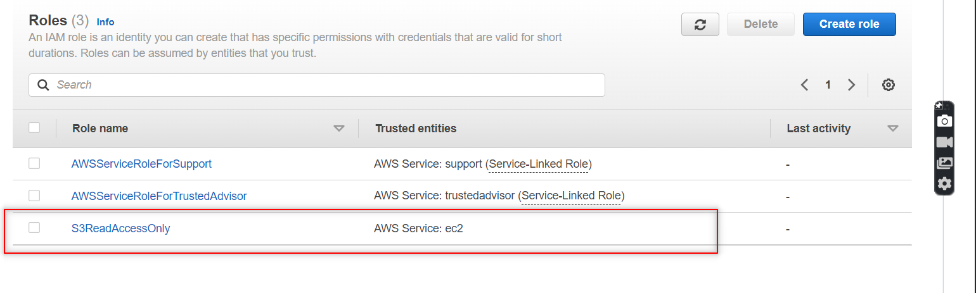

1. **Launch amazon linux 2 with user data.?**

**Now create one amazon linux EC2 instance along with user data.**

**Provide name n kp.**

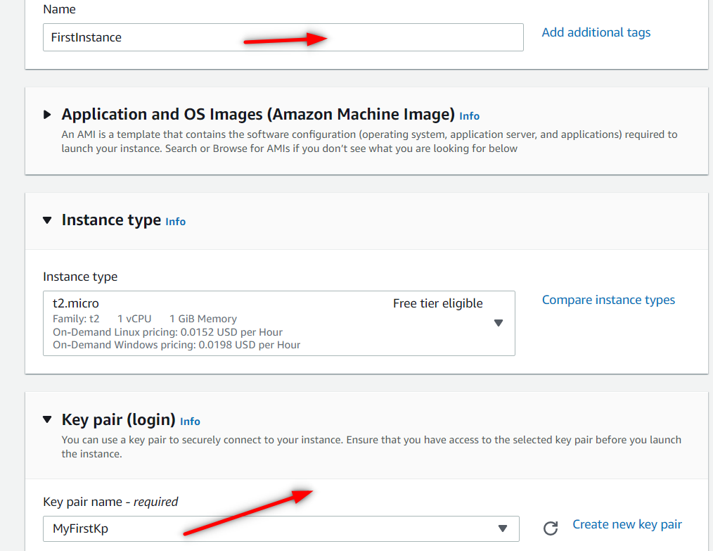

**Under network settings , allow http traffic ..**

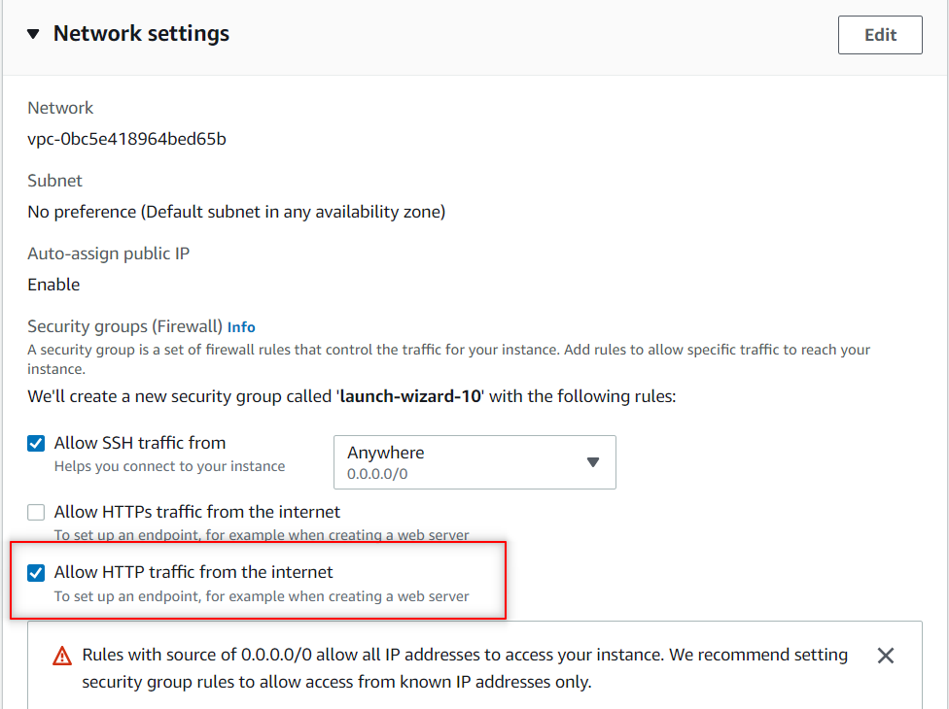

**Here add the S3ReadOnlyAccess that u created in IAM Role.**

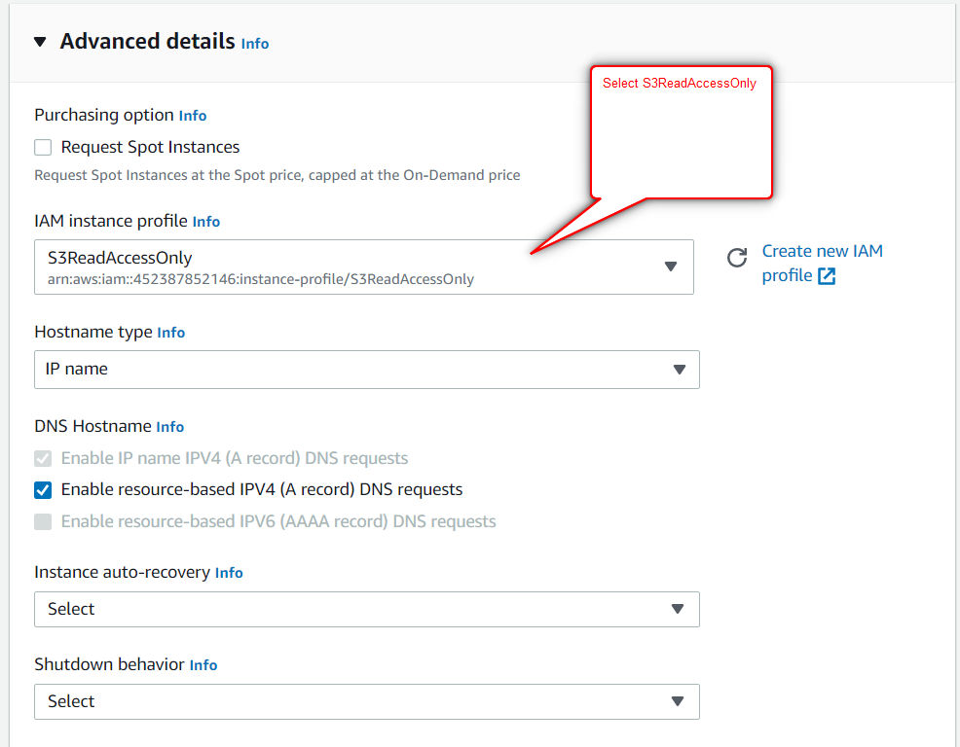

**And provide the commands which executes automatically while launching the instance and click on launch instance..**

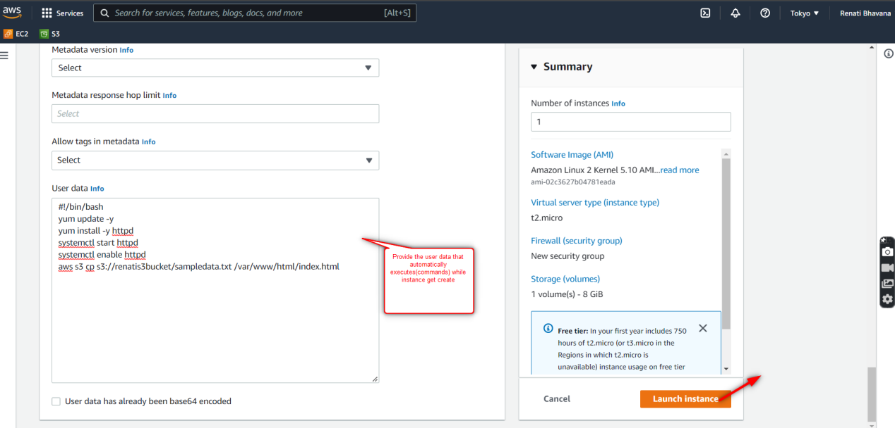

**The instance get created.here go to storage and see the volume ID and as well check the availability zone that u created the instance.**

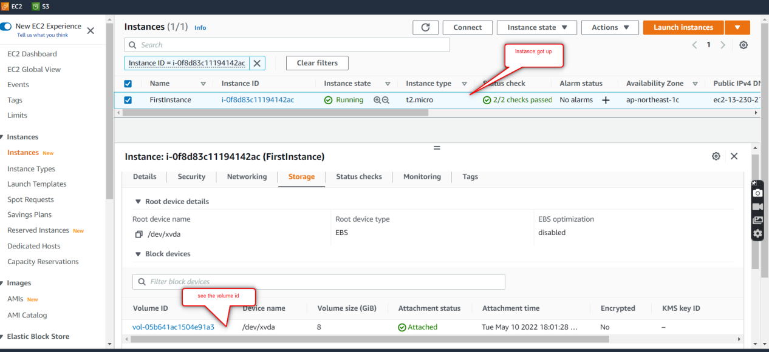

**Copy the public IP and paste it in google , u can see the output that the user uploaded the file in bucket.**

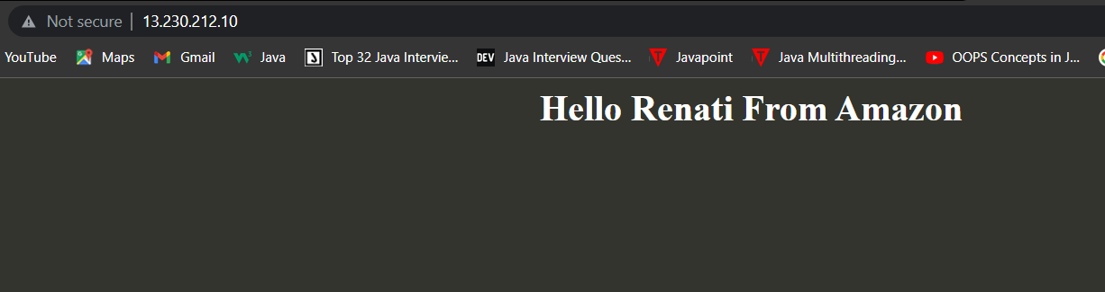

1. **Create a snapshot from the volume.**

**From the created instance . create the snapshot from the root volume.**

**Go to volume which is present in the left side and go to actions as shown in below and click on create snapshot.**

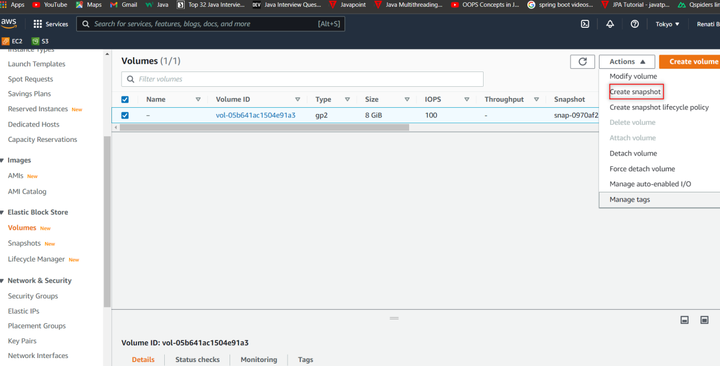

**Provide the description and click on create snapshot.**

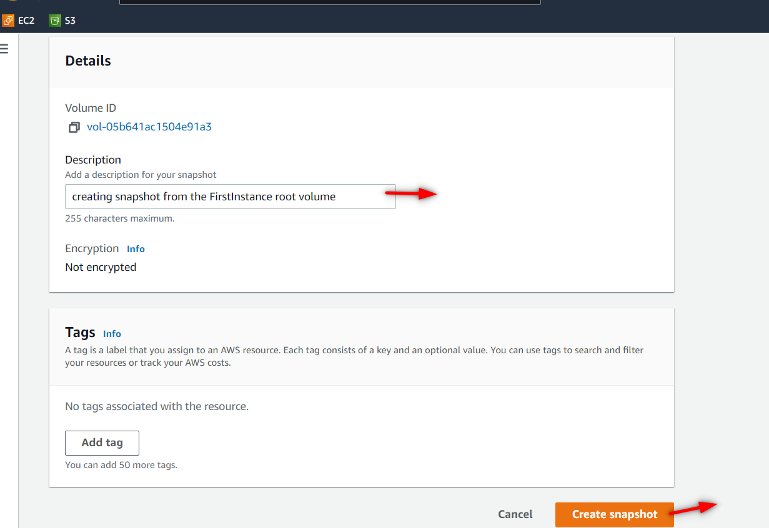

**Here u can see the snapshot got created.**

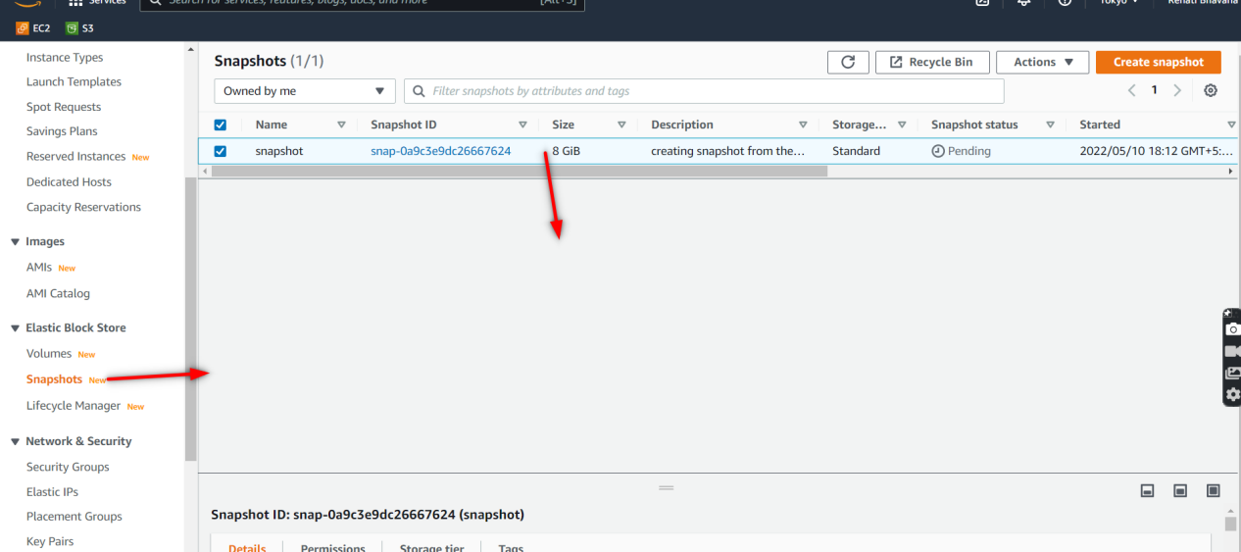

1. **Create AMI from the sanpshot created ?**

**Go to that snapshot and click on create image from snapshot.**

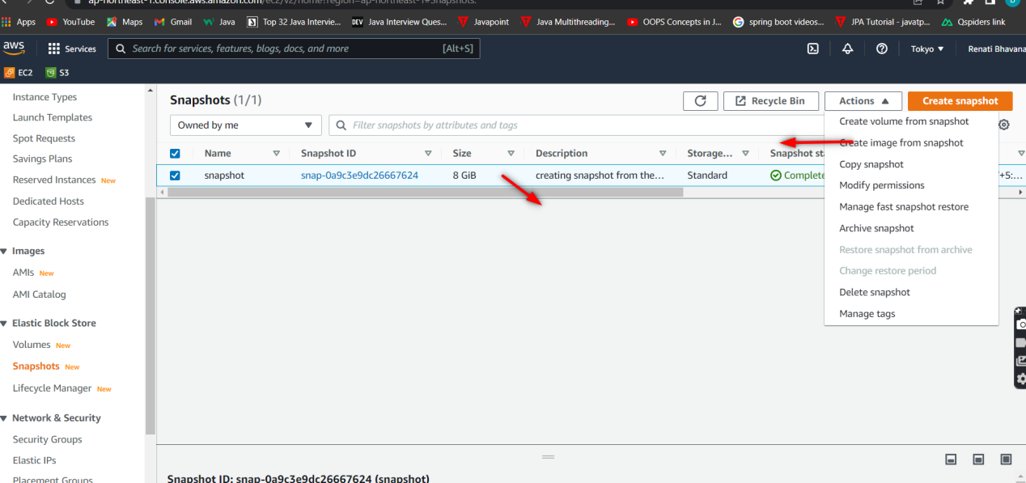

**Provide image name and description and click on create.**

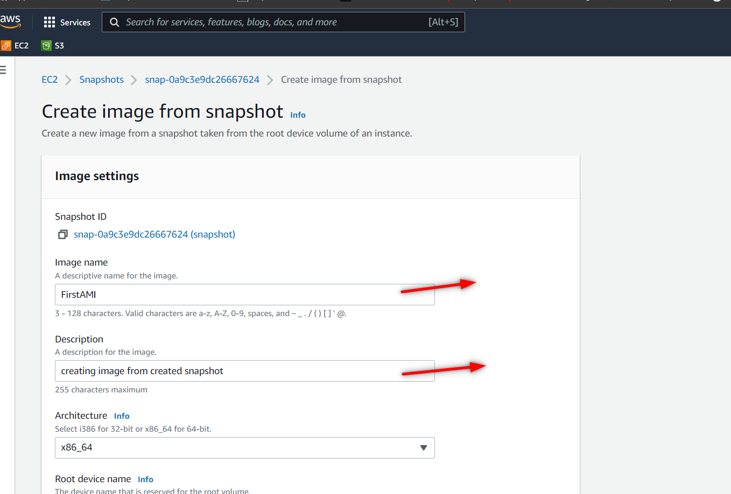

**Here u can see that the image got created from snapshot.**

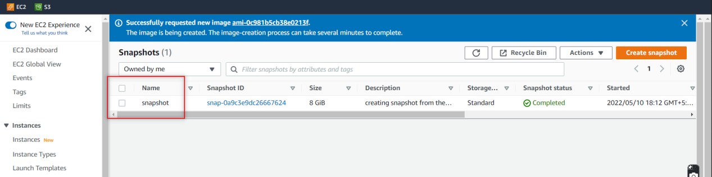

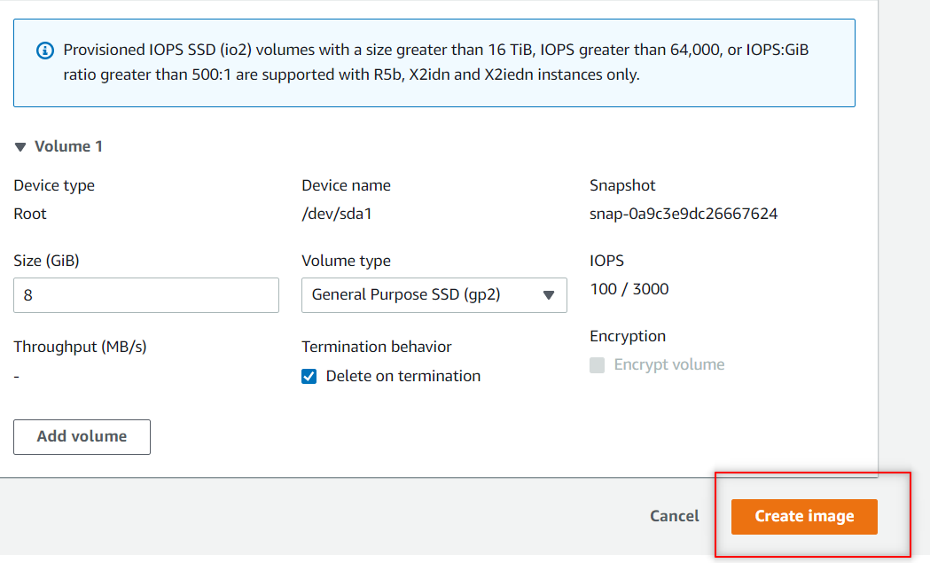

1. **Launch EC2 instance from the created AMI in different AZ**

**Go to AMI and click on launch instance from AMI**

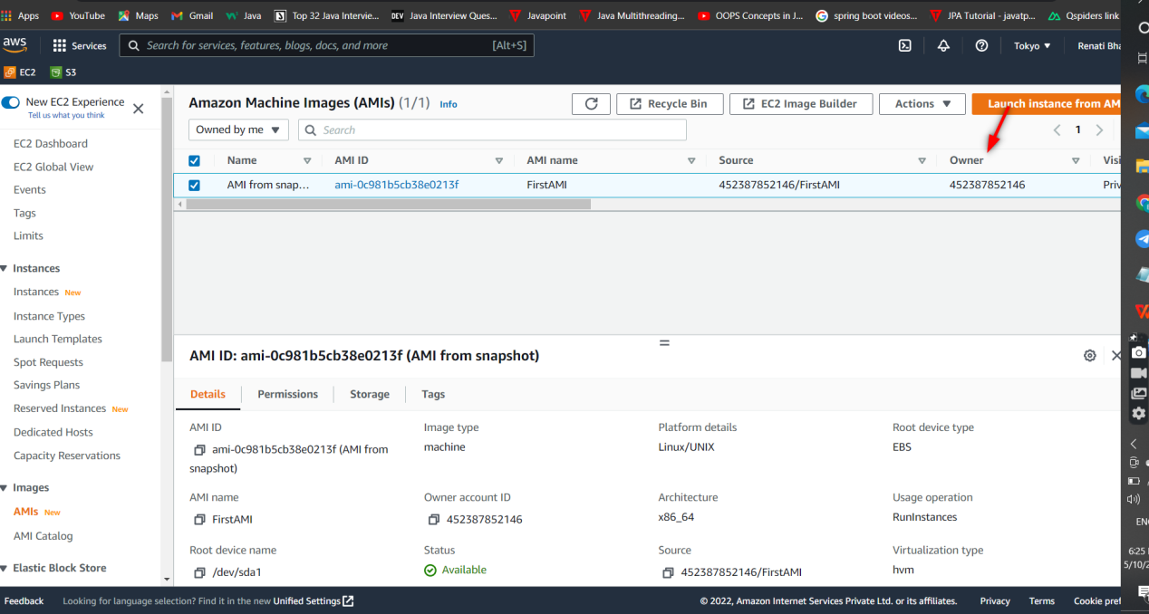

**Provide name and KP .**

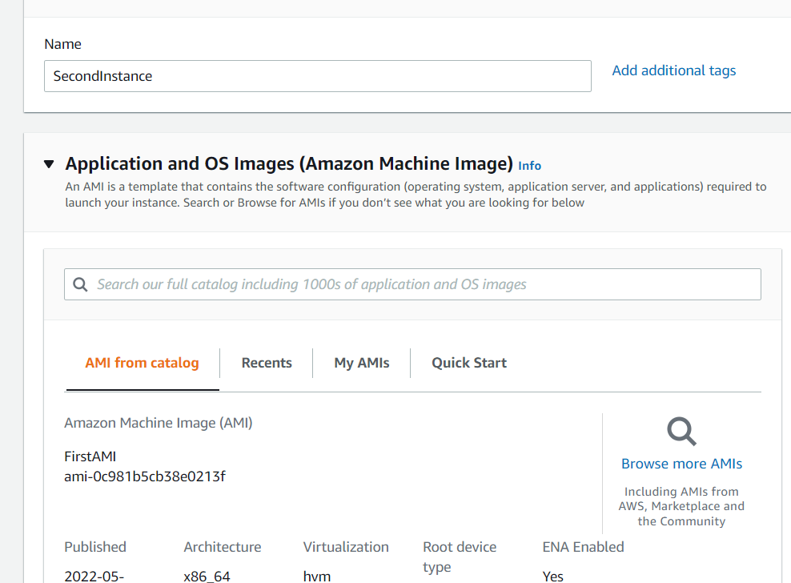

**Under network settings tab choose subnet that is different from the first instance that u created. and allow http traffic as well and click on launch instance.**

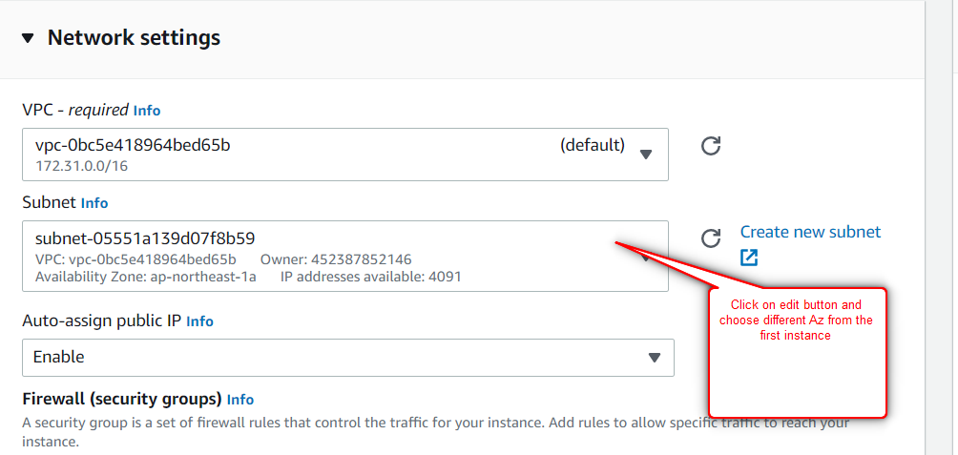

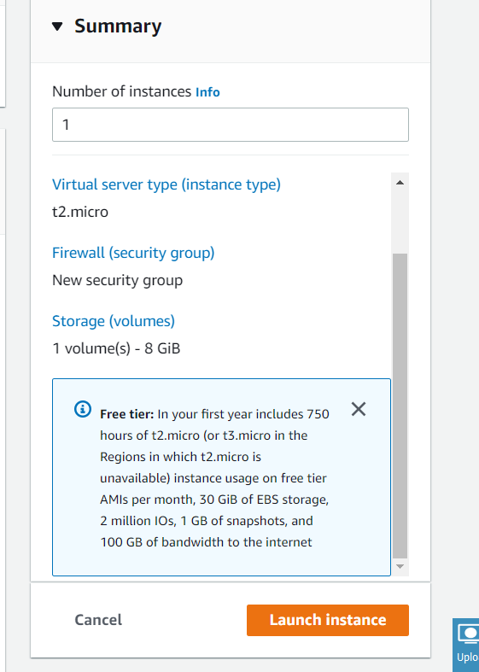

**The second instance also created and copy the Public Ip and paste it in google.**

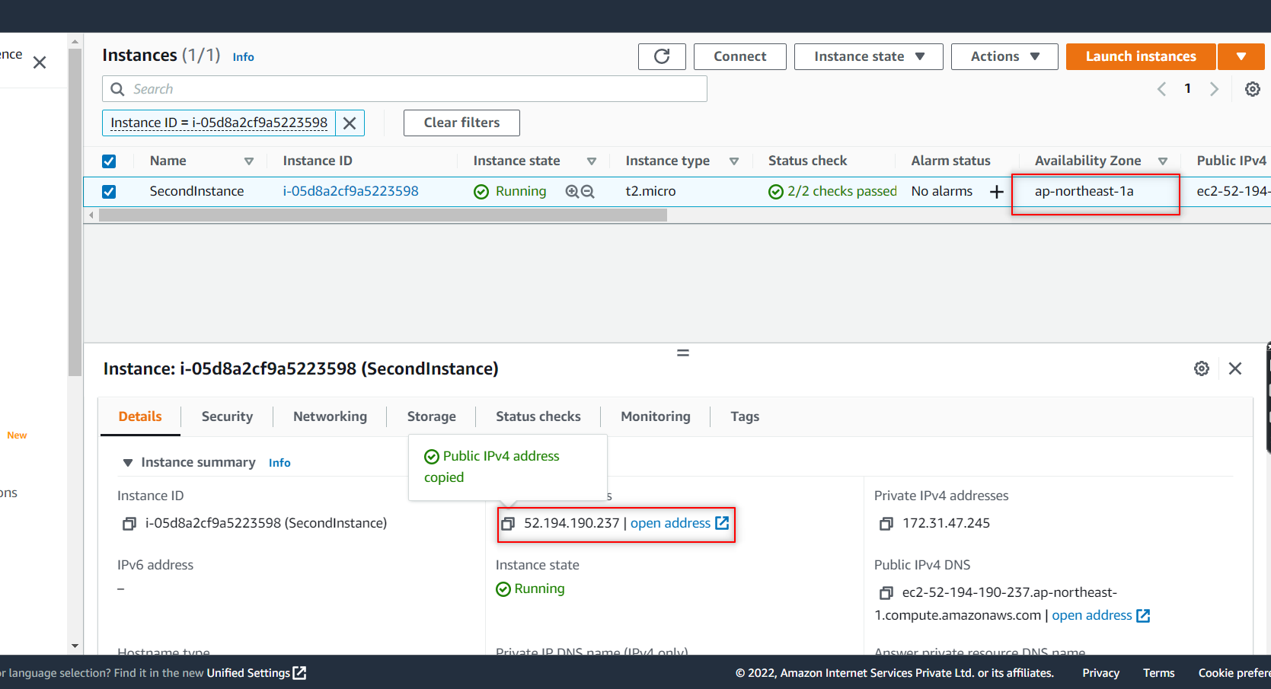

**The other way to provide the secutity is :**

**Go to security tab and clcik on security group link and click on edit option in Inbound rules and click on add rules and provide http , 80-port and 0.0.0.0/0 and save it**

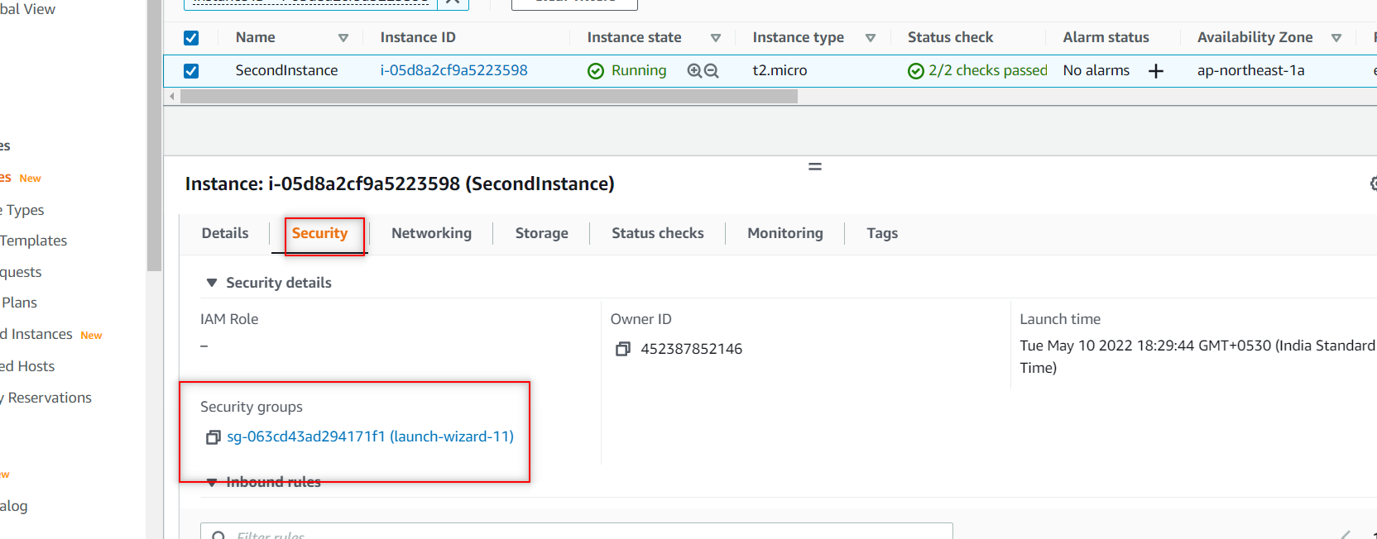

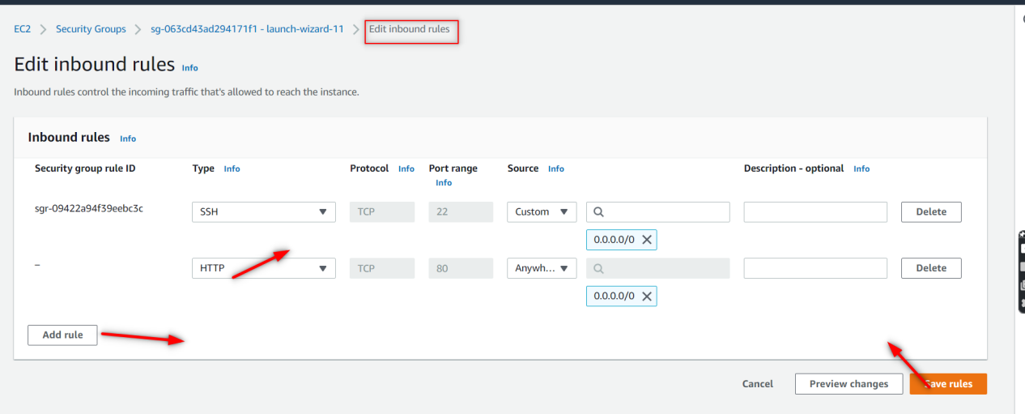



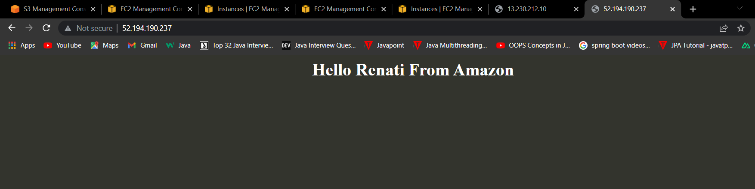

1. **What is Same region Replication(SRR)?**

Same-Region Replication (SRR) is **used to copy objects across Amazon S3 buckets in the same AWS Region**. SRR can help you do the following: Aggregate logs into a single bucket – If you store logs in multiple buckets or across multiple accounts, you can easily replicate logs into a single, in-Region bucket.

1. **What is Cross Region Replication(CRR)?**

* Cross Region Replication is a feature that replicates the data from one bucket to another bucket which could be in a different region.
* It provides asynchronous copying of objects across buckets. Suppose X is a source bucket and Y is a destination bucket. If X wants to copy its objects to Y bucket, then the objects are not copied immediately.

****Some points to be remembered for Cross Region Replication****

* ****Create two buckets:**** Create two buckets within AWS Management Console, where one bucket is a source bucket, and other is a destination bucket.
* ****Enable versioning:**** Cross Region Replication can be implemented only when the versioning of both the buckets is enabled.
* ****Amazon S3 encrypts the data in transit across AWS regions using SSL:**** It also provides security when data traverse across the different regions.
* ****Already uploaded objects will not be replicated:**** If any kind of data already exists in the bucket, then that data will not be replicated when you perform the cross region replication.

**9. How to delete a snapshot??**

**To delete a snapshot make sure first u deregister the image that u created.**

**Now click on the snapshot and go to actions button and choose delete snapshot to delete.**

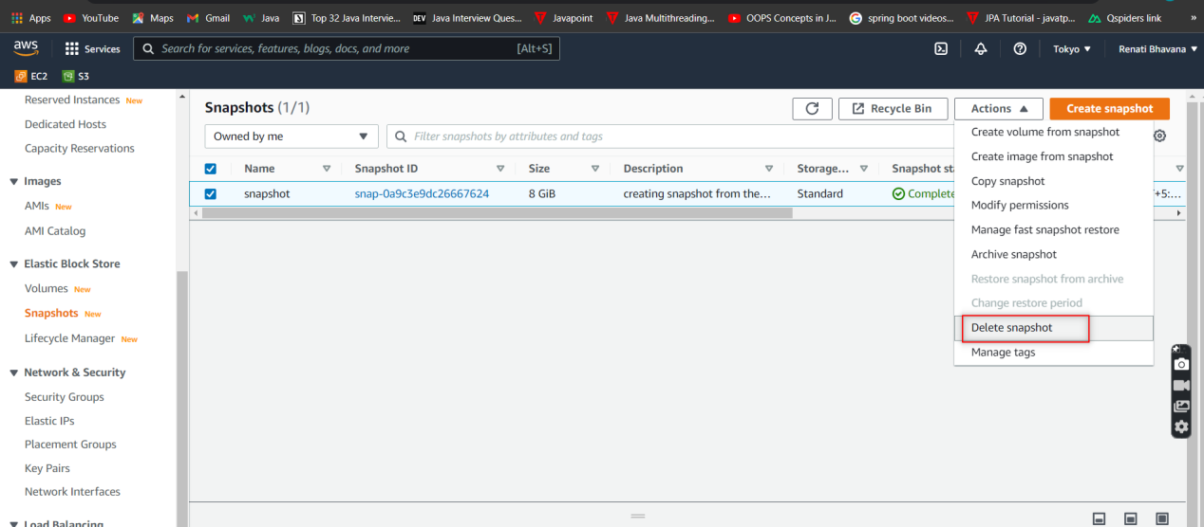

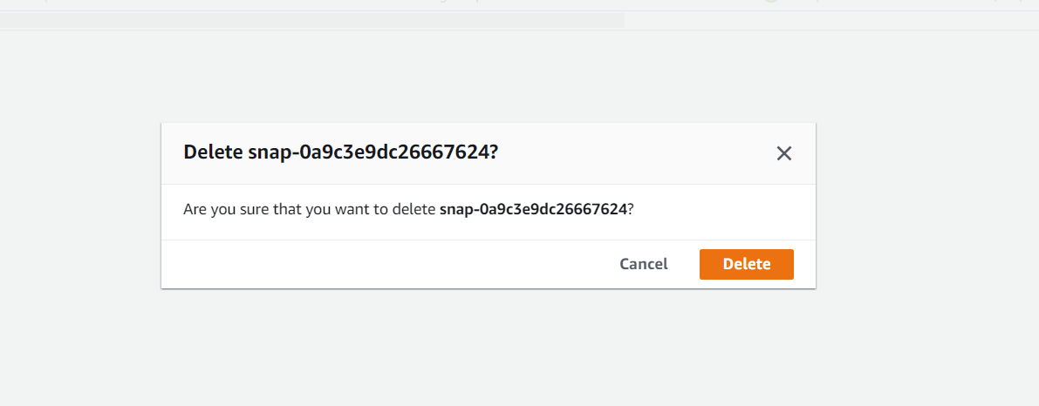

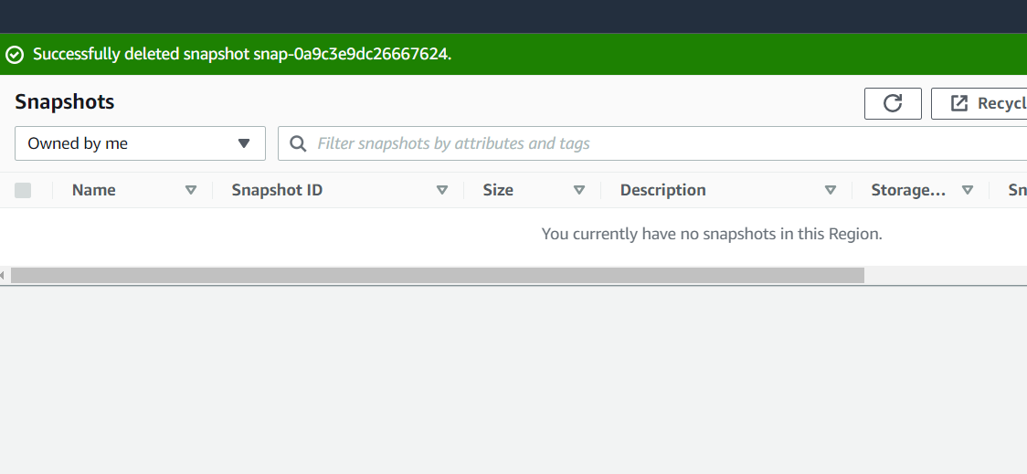

1. **HOw to deregister your AMI?**

**Click on the created Image and go to Actions and click on Deregister AMI . The AMI get deleted.**

